
Herga
at The Castle

30 West St, Harrow HA1 3EF
Monday 26th October 2026 8 PM
Sue Conroy and Hazel Richings
Entrance £12
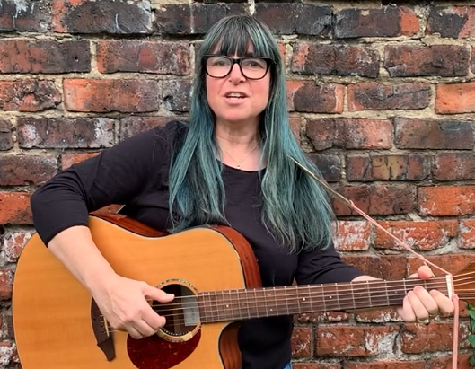
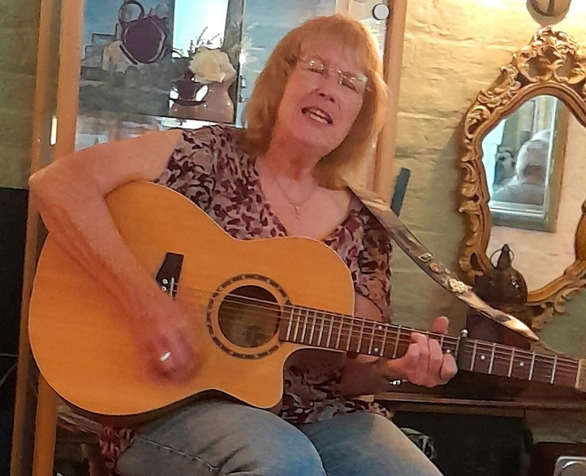

A double-header evening featuring the vocal and songwriting talents of Sue Conroy, an acclaimed songwriter from Middlesborough, and the golden voice of Hazel Richings (Hissy Fit, CHAS, and celebrated ‘Reidette’). Expect an evening of great variety!



