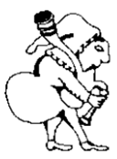
Herga
at The Castle

30 West St, Harrow HA1 3EF
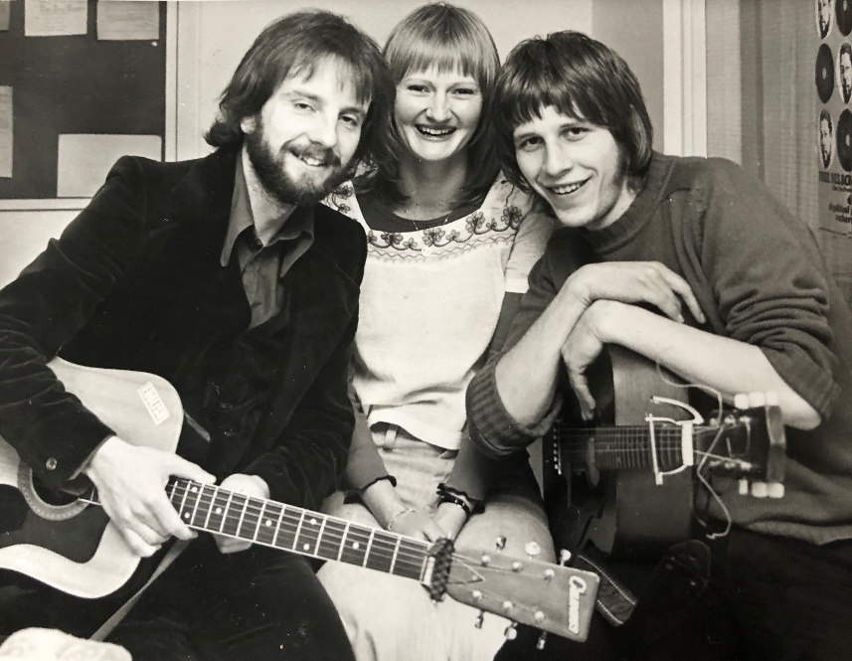

Monday 3 August 2026 8 PM
Tribute evening to the late Martin Atkins, featuring Roger West
Entrance Free
[Donations accepted St Luke's Hospice (Harrow and Brent) as requested by Janet]

Roger (L) and Martin (R) in their trio ‘Inside Leg’ back in 1972
Roger will reprise some of the songs that Martin and he wrote for their band back in the day! Janet will sing some songs too!

