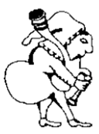
Herga
at The Castle

30 West St, Harrow HA1 3EF
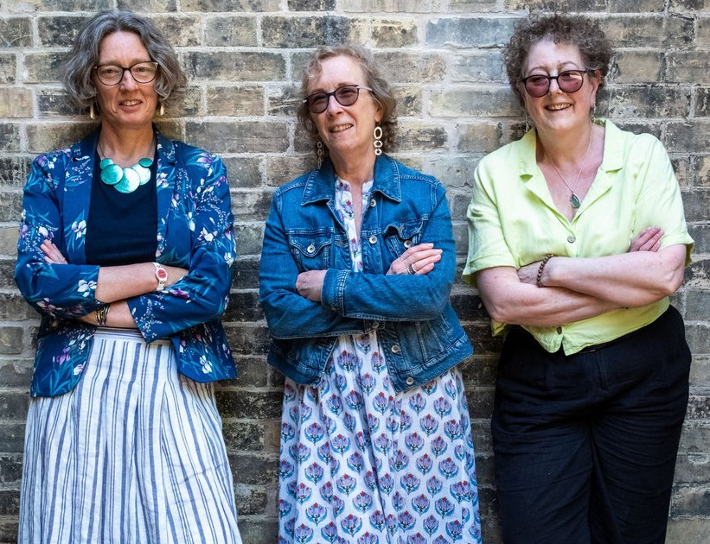
Monday 6 July 2026 8 PM
Rumpled Muslin
Entrance £10

Rumpled Muslin are a highly accomplished and entertaining all-female trio who sing in glorious folk harmony with strong solo leads. The group are steeped in the traditions of folk music, from England, Scotland, and further afield, and deliver ballads and comic songs with equal sincerity. The contemporary songs in their repertoire feel as if they have always been with us.
Amanda MacLean, Alison Frosdick and Wendy Lanchin have many years of musical experience between them and it shines through every aspect of their performance. The blend of their voices is highly effective and with impeccable timing and great storytelling the three sound like they have been singing together much longer than just four years.


