Optimizing Zoom settings for musical meet-ups
Green highlights show navigation from one screen to the next
Red highlights show required settings

FOR PC Users (Desktops and laptops – probably valid for Apple Macs as well)

1A To change the settings when not in a meeting
Open Zoom application and from the home screen click on the ‘settings’ Icon in the top left corner
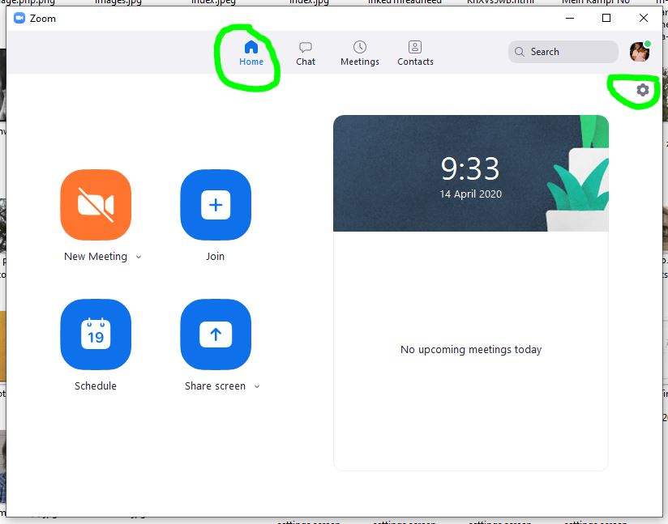
From the settings screen click on Audio
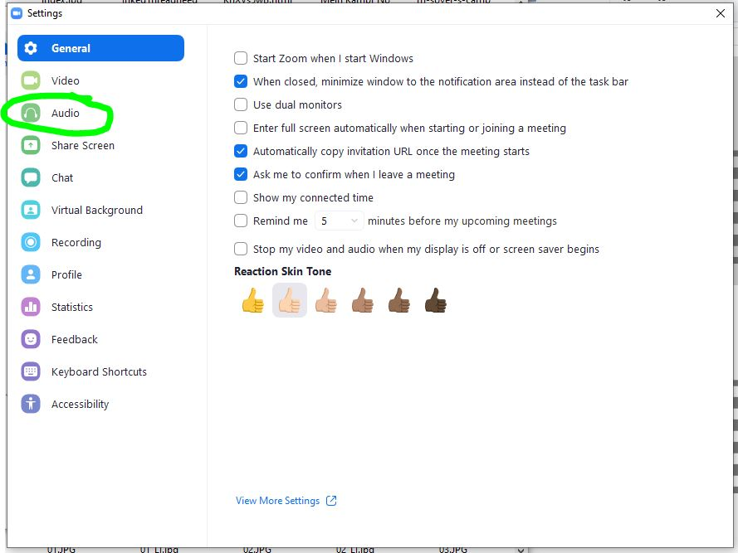

1B - To change the settings when already in a meeting
Click on the ‘ ˄ ’ symbol next to the microphone symbol at the bottom left of the page.
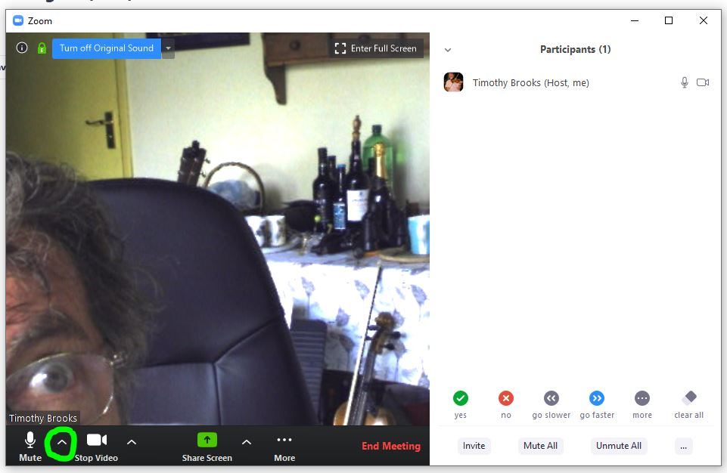
Then click on the ‘audio settings’ prompt at the bottom of the pop-up list which appeared

2 - On the Audio screen make sure the “Automatically adjust volume” indicator box is unticked , then click on the ‘advanced’ button.
(note that if you have previously used zoom the volume level is probably already set at an optimal level – but if people complain in a meeting that you can’t be heard, or are too loud, it can be manually adjusted from now on)
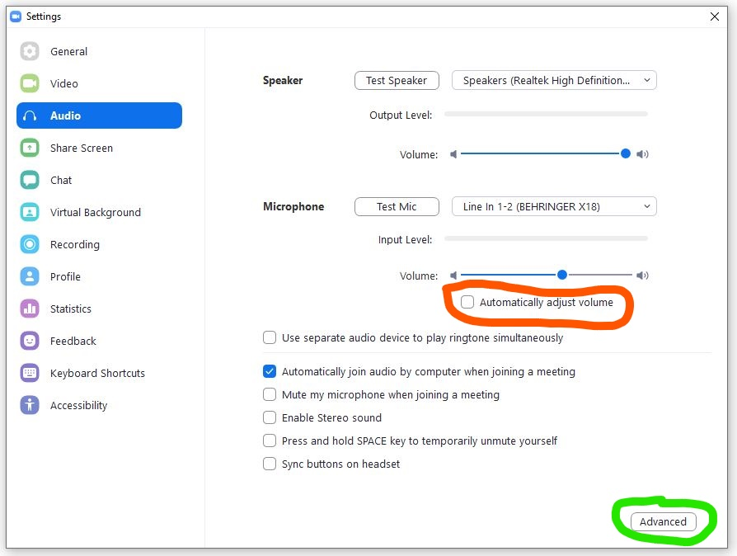
3 Make sure the settings are all as shown in this screen shot below.
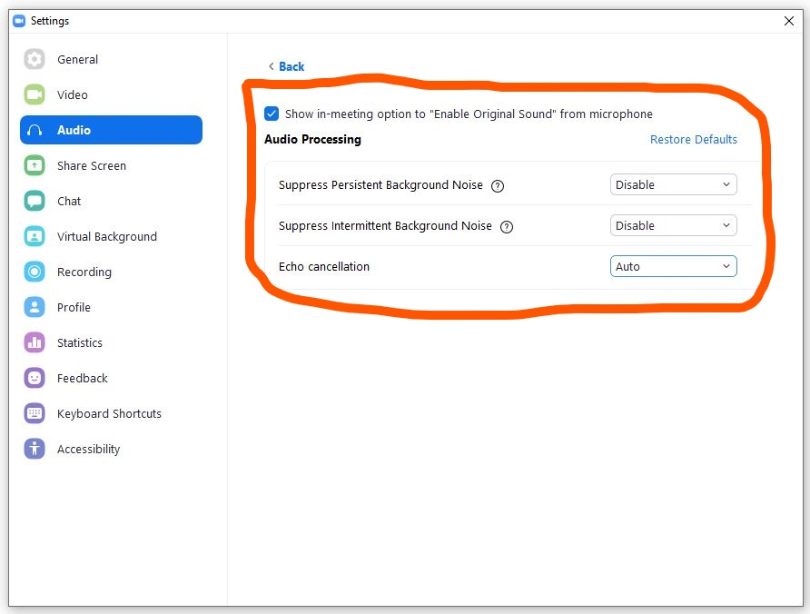

4 Close the settings screen by clicking on the ‘ x ‘ at the top left-hand corner
Your settings will have been saved automatically.

5 Once in the meeting
Make sure that the Blue Box at the top left of your screen says ‘ Turn off original sound’
(This means that ‘original sound’ is switched on.)
If it says ‘Turn On original Sound’ then click on it to toggle it to the on state.

If you are using a mobile phone,
Your options are few - and cannot be changed (as far as I know) while in a meeting. Open Zoom, and touch on the settings symbol at the top left.
Touch on the > symbol labelled 'meeting'
make sure that 'Use Original Sound' is on.
I don't recommend taking advantage of 'Safe Driving Mode' - at least not if you are playing your instrument as an accompaniment while you sing and drive !!!!

