Installing Zoom – from version 5 onwards

Use this link to Download and then run Zoom Client for meetings

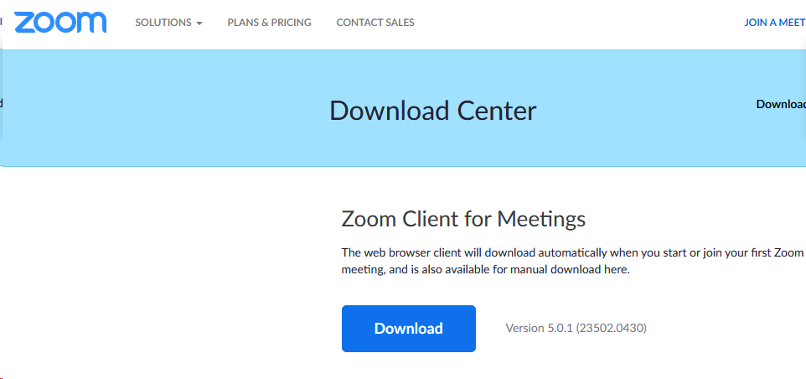

The first time I started zoom after the upgrade I was presented with this screen...
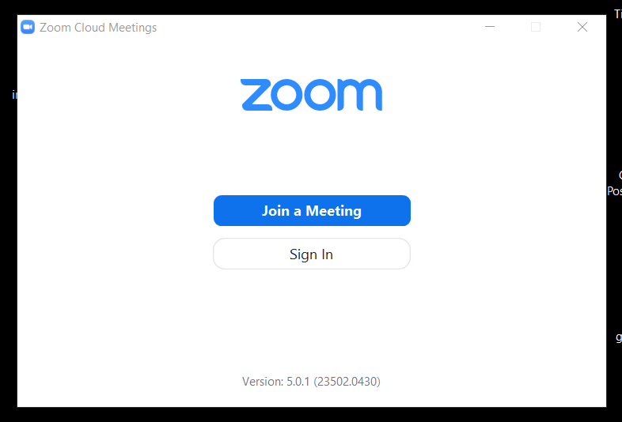

Click on the ‘Sign in’ button to get to this next screen
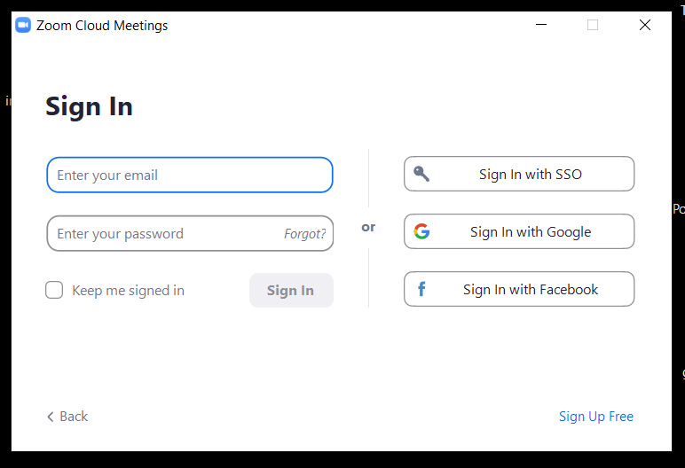

Rather than give Zoom your e-mail address and e-mail password (Note this is not the meeting password) , I recommend that you use the ‘Sign in with Google’, or the ‘Sign in with facebook’ option, but it’s your choice!
Once you have signed in you see this familiar screen.
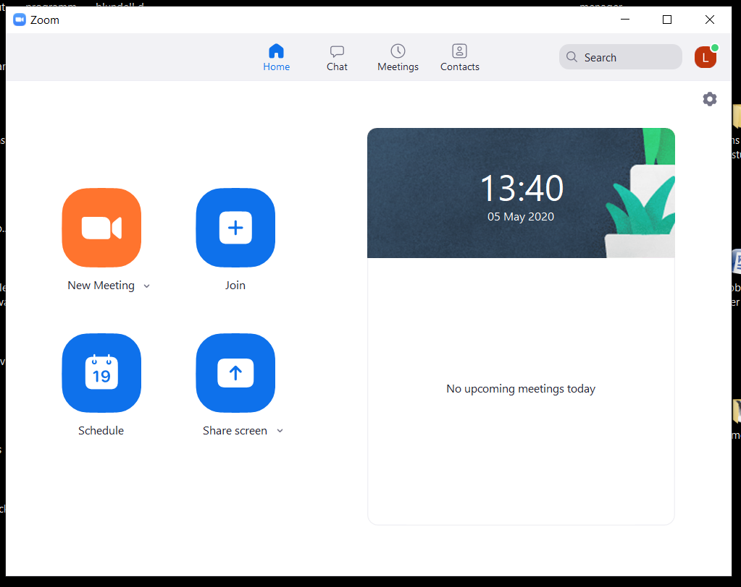
My experience has been that the next time I start Zoom 5 , I get straight to this last screen.

