To join Zoom without installing the Zoom app
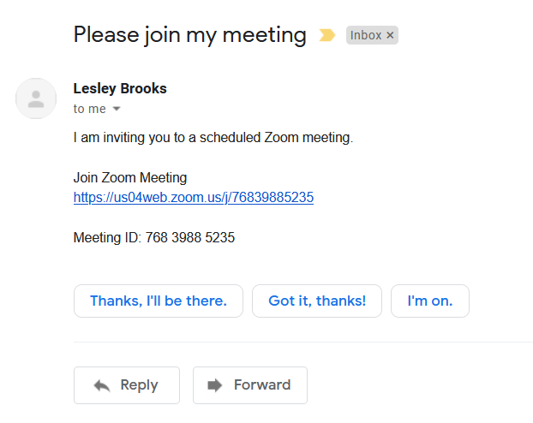
Click on the link you have been given. (or copy and paste URL into browser if it’s not a link)
You don’t need to remember the meeting ID or password if there is one.
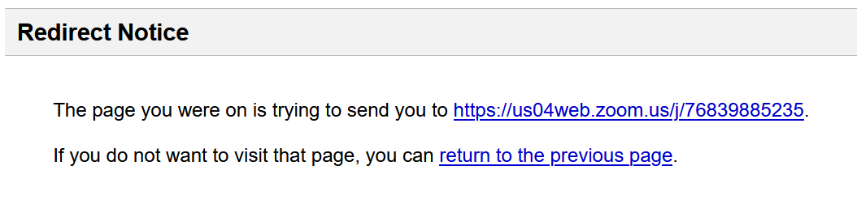
If you get this redirect message then click on the link again (end of first line)

Then you will get this screen - if necessary close the video preview box – and any other boxes which appear
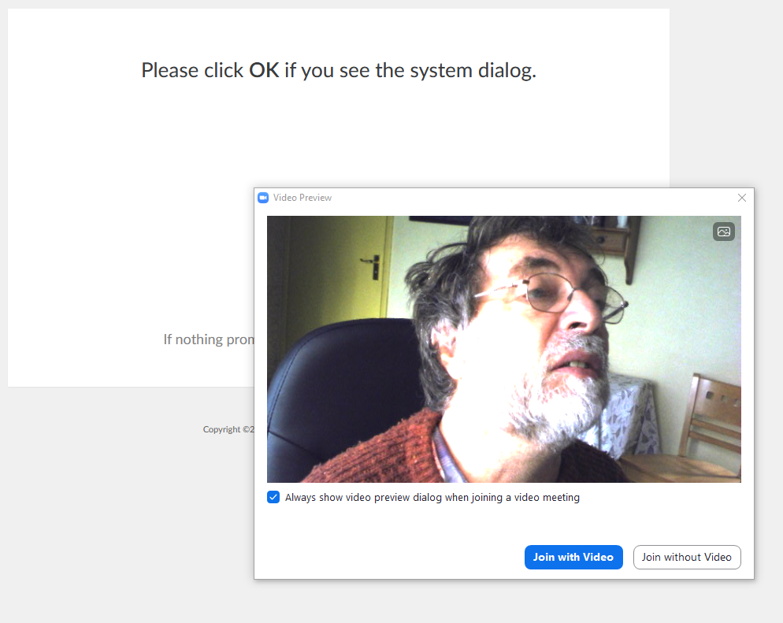

Until you are left with .......
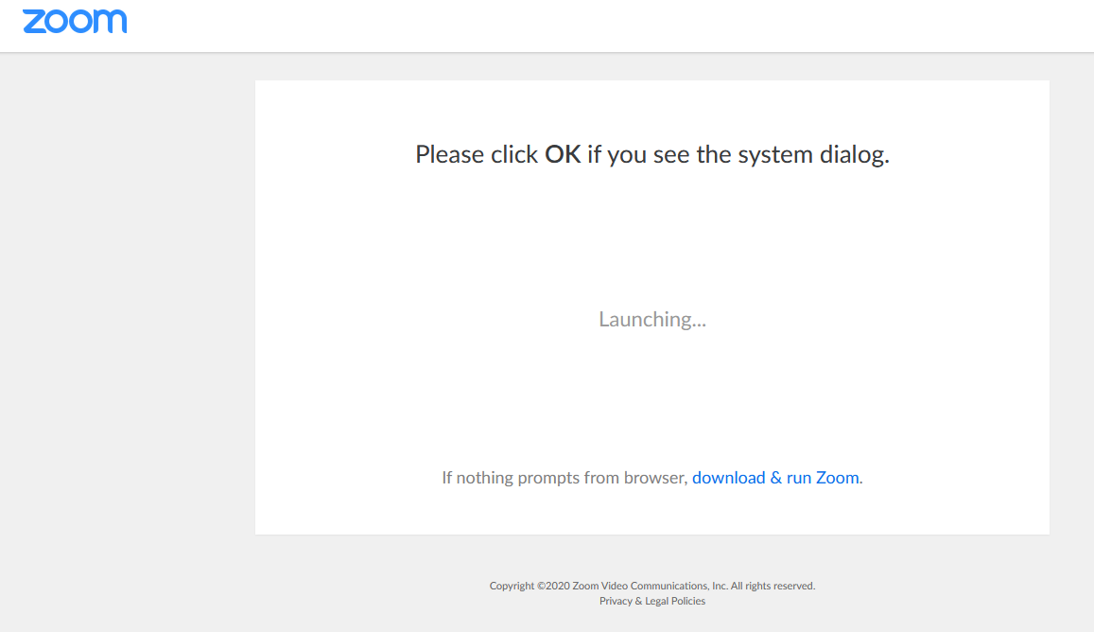
Click on ‘Download and then run zoom’ and this prompt appears – Click on ‘Cancel’
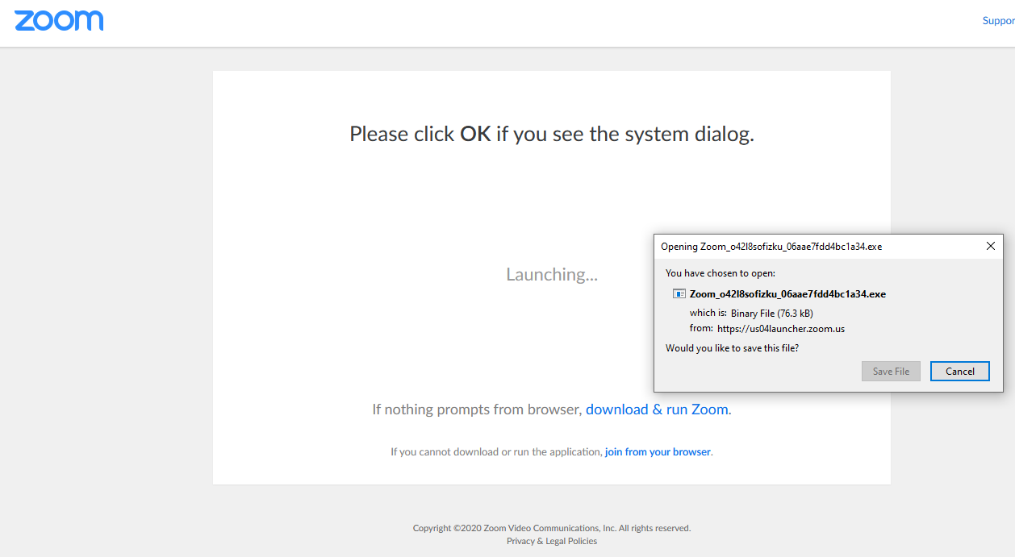
You will see that an extra line of text has magically appeared!
From this screen click on the ‘Join from your Browser’ link – not ‘Download and Run Zoom’
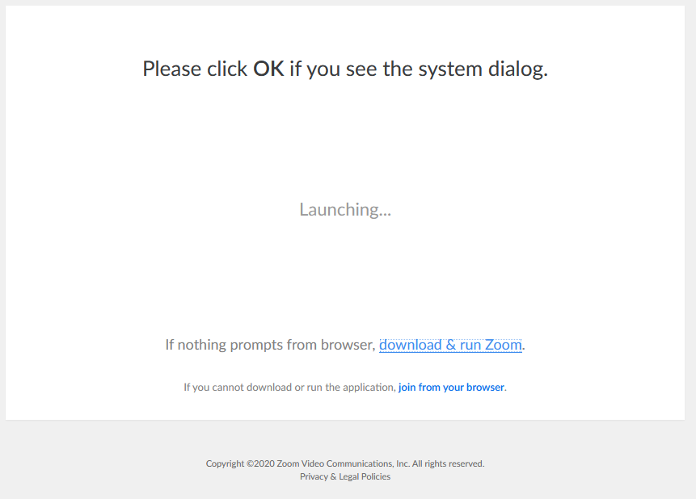

On the next screen add you name and tick the ‘I am not a robot ‘ box, and then ‘Join’
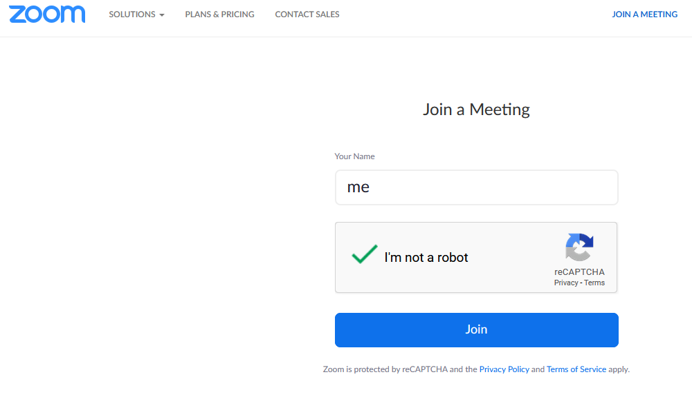
On the next screen Click on ‘I agree’
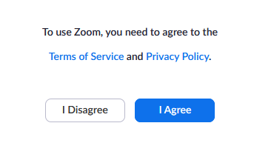
You may then have to wait until the host admits you – if this is the case there is a prompt box that tells you this.
Et Voila! You are in!

